**CSA1054 Software Engineering**

**LAB EXPERIMENTS**

**NAME: Gurramkonda Asif**

**Reg number: 192211247**

1. **EXPERIMENT NUMBER 1:** Draw a use case diagram to model for Online Voting System. A web-based voting system that will help to manage elections easily and securely, the voter should be able to successfully cast his vote or it should be a failure. There should be no intermediate state. In case of failures the voter should be allowed to retry immediately. The voting data should be consistent throughout the system. If we are replicating the data, we do not want any scenario where one database shows Voter-1 has voted Candidate-1 and another database has an old entry for Voter-1 showing he has voted for Candidate-2. We should always have strong consistency.

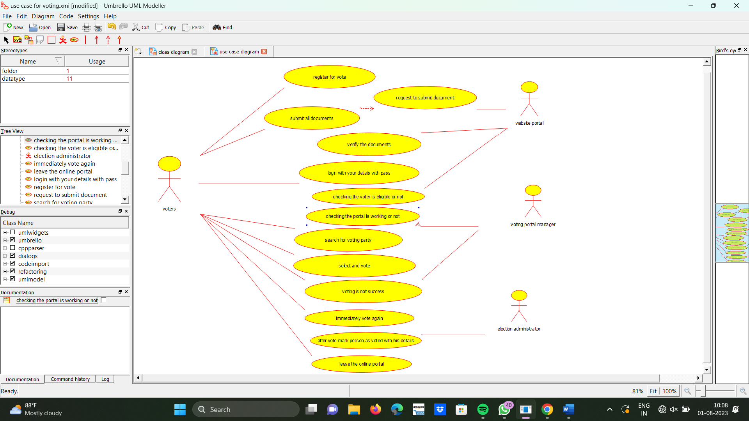

**EXPERIMENT NUMBER 2:** Draw a use case diagram for Library Management System is an automation system used to manage a library and the different resource management required in it like cataloguing of books, allowing check out and return of books, invoicing, user management, etc. The user can search for book details using a few book properties (Book ID, Title, Author, and Publisher). Searching should return details about all the book copies that match the search query.

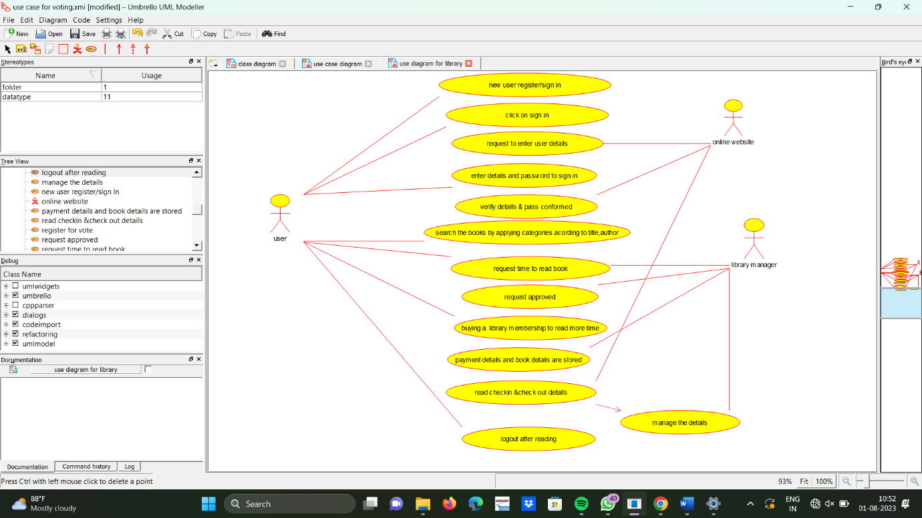

**EXPERIMENT NUMBER 3:** Draw the use case diagram is a graphic depiction of the interactions among the elements of the Railway reservation system for maintaining admin user can search ticket, view the description of a selected ticket, add a ticket, update a ticket and delete a ticket and it shows the activity flow of editing, adding and updating of the customer. The user will be able to search and generate reports of payment, Booking and train schedules.

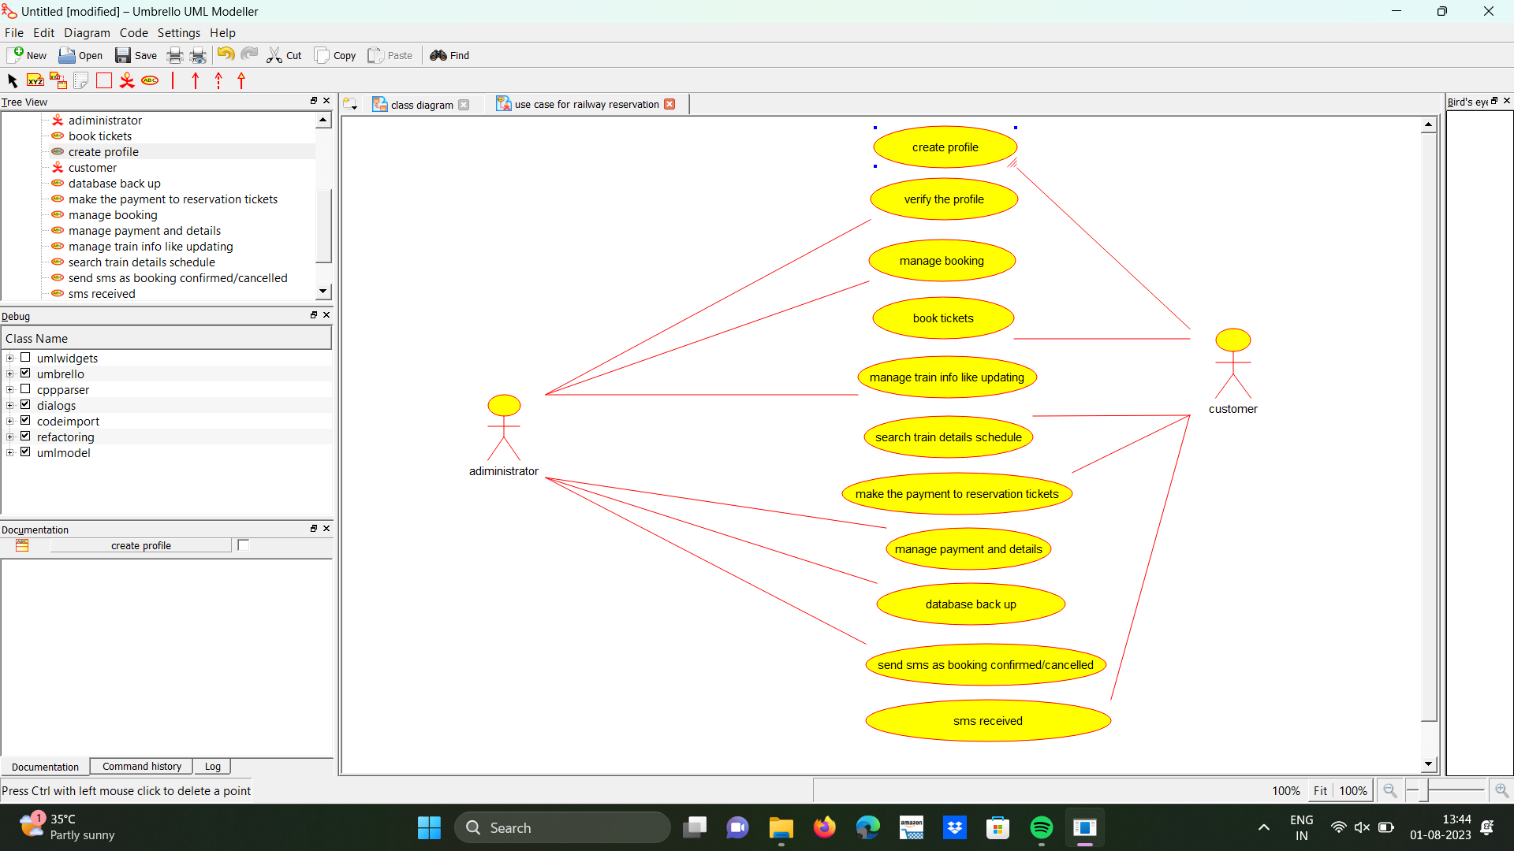

**EXPERIMENT NUMBER 4:** Draw a USE-CASE diagram for the Hospital System. The activities of the hospital system are listed below. Receive the patient id, Patient name, pharmacy, laboratory, doctor, administrator, record officer, test report, drug management, test management, user management, dispense drug using CASE tools.

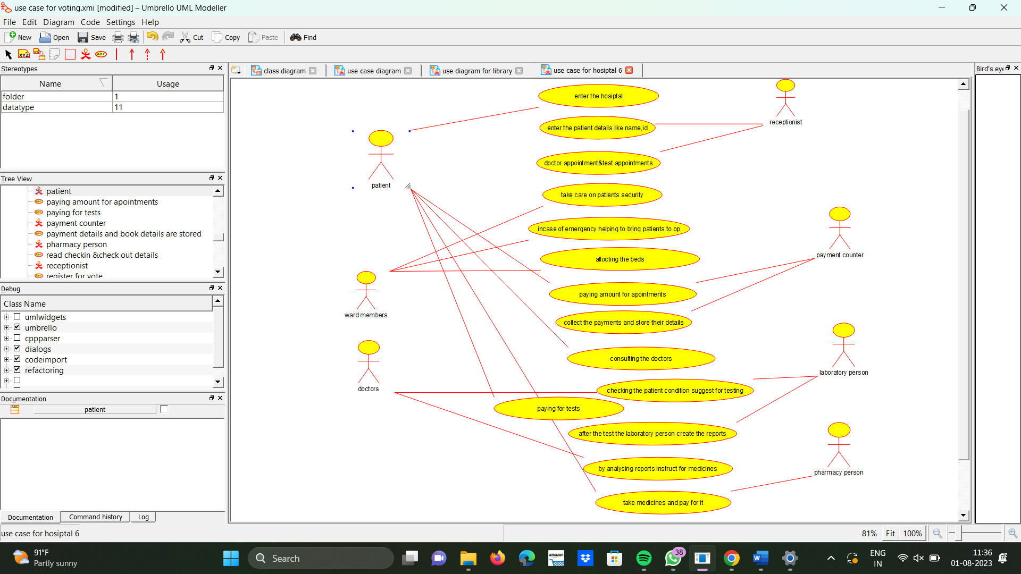.

1. **EXPERIMENT NUMBER 5:** Draw a USE-CASE diagram for an ATM System using CASE tool. The banking system allows a customer to access the financial transactions by ATM System; it has a step-by-step process describing the work of this process and elaborates what work can be done by customer, banking system, administrator and technicians with the ATM system.

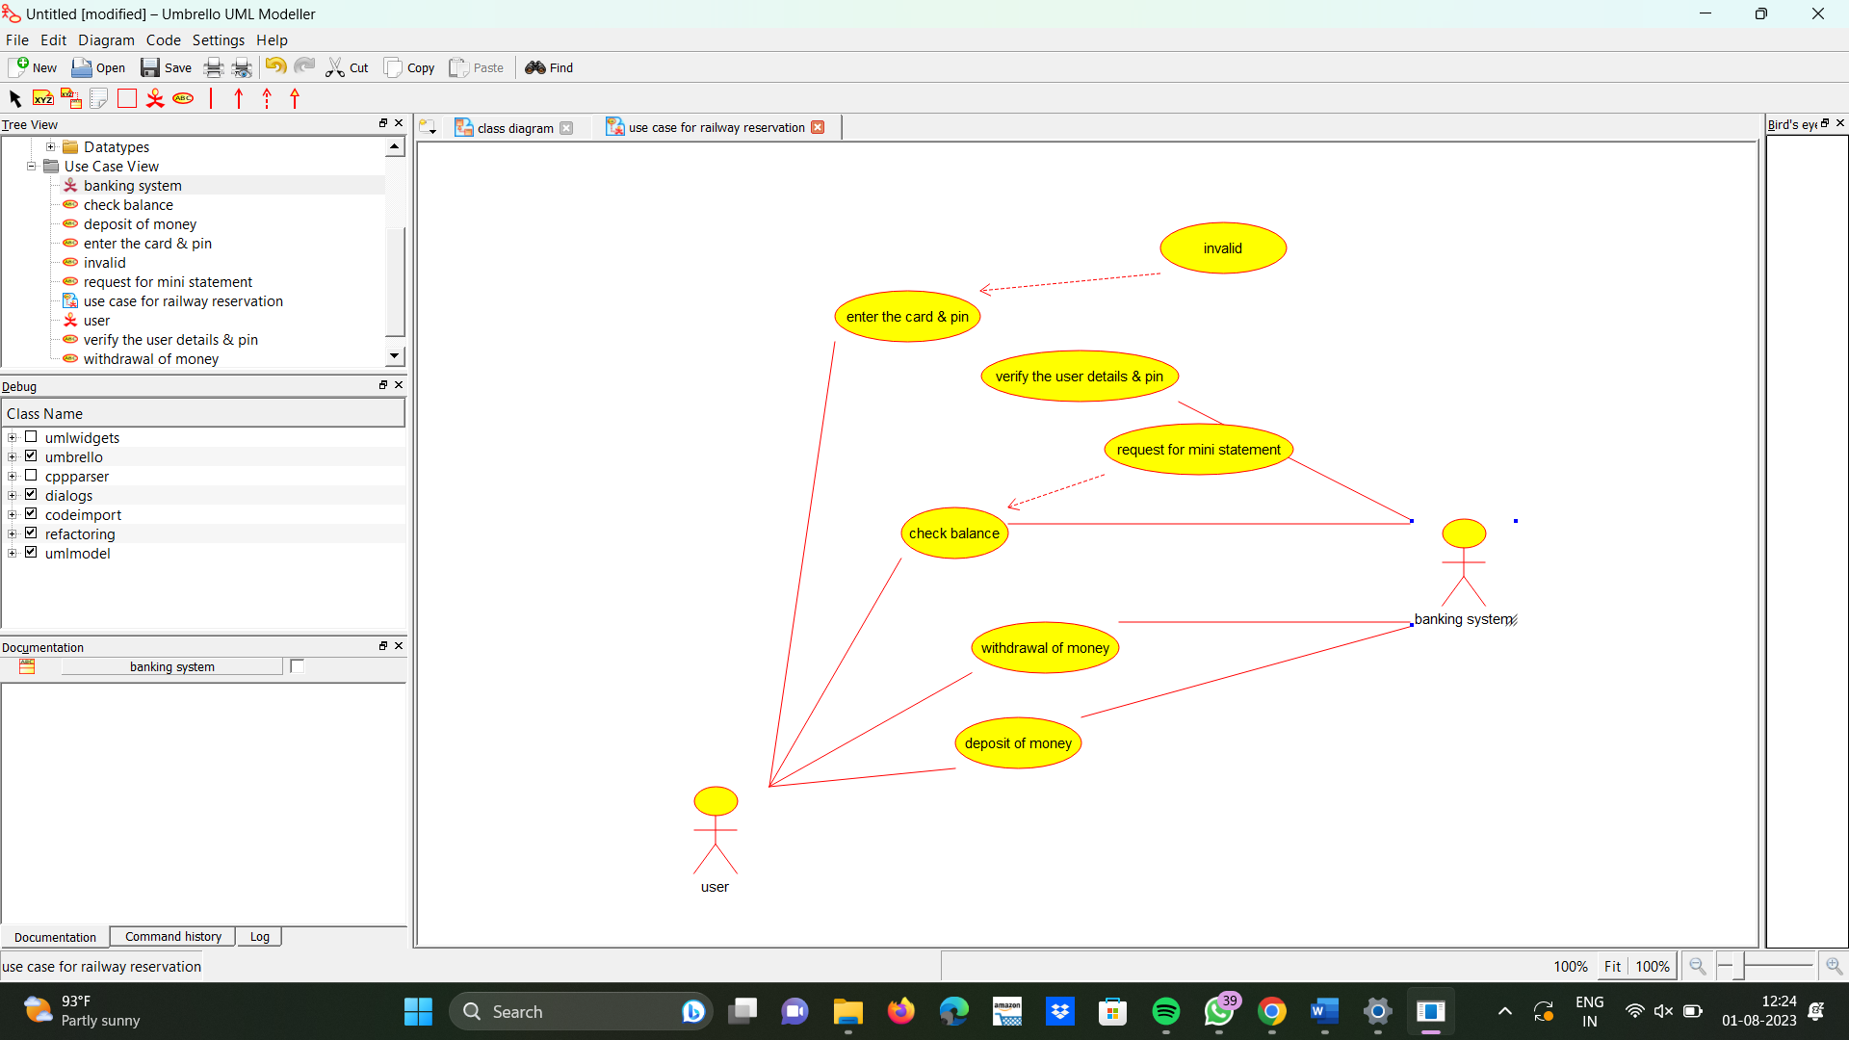

1. **EXPERIMENT NUMBER 6:** Draw a USE-CASE diagram for Online college management System Manage student’s information and status, manage courses and subjects, Manage Instructors and designation, record all transactions draw a USE-CASE diagram for online Airline management System which is a dedicated and highly configurable system for all airlines, which can be easily accessed by all users. It helps the users to book flights without visiting offline booking counters. This system can be accessible by any user from any location at any time. In such a system, a passenger should be able to view the availability of flights’ details, as per their requirement. They can book the flights online and can also cancel the reservation. The administrator manages the passenger booking system and updates the reservation status using CASE tools.

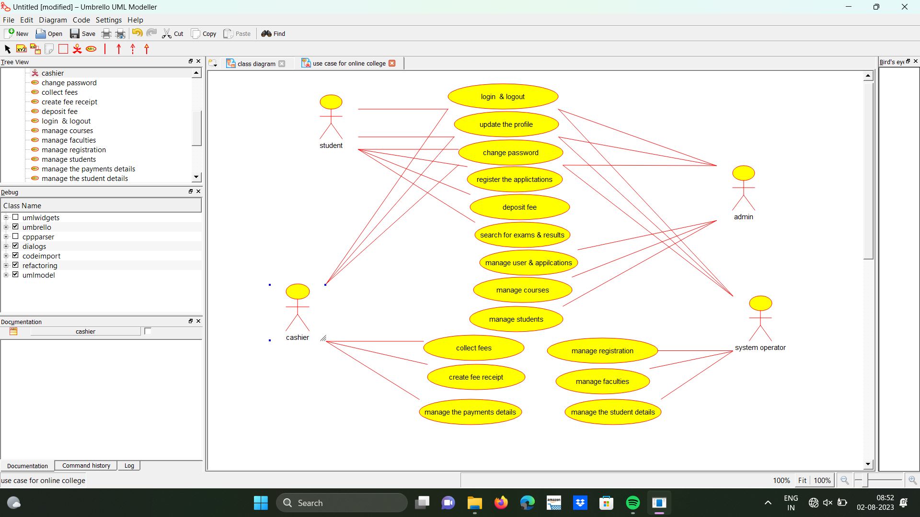

**EXPERIMENT NUMBER 7:** Make an Online Airline Reservation System. The activities of the Online Airline Reservation system are listed below user, admin, LOGIN, MANAGE CLASSES, MANAGE WAITING LIST, MANAGE HOLDS, MANAGE DEADLINES, LOGOUT, using this has a step-by-step process draw a USE-CASE diagram.

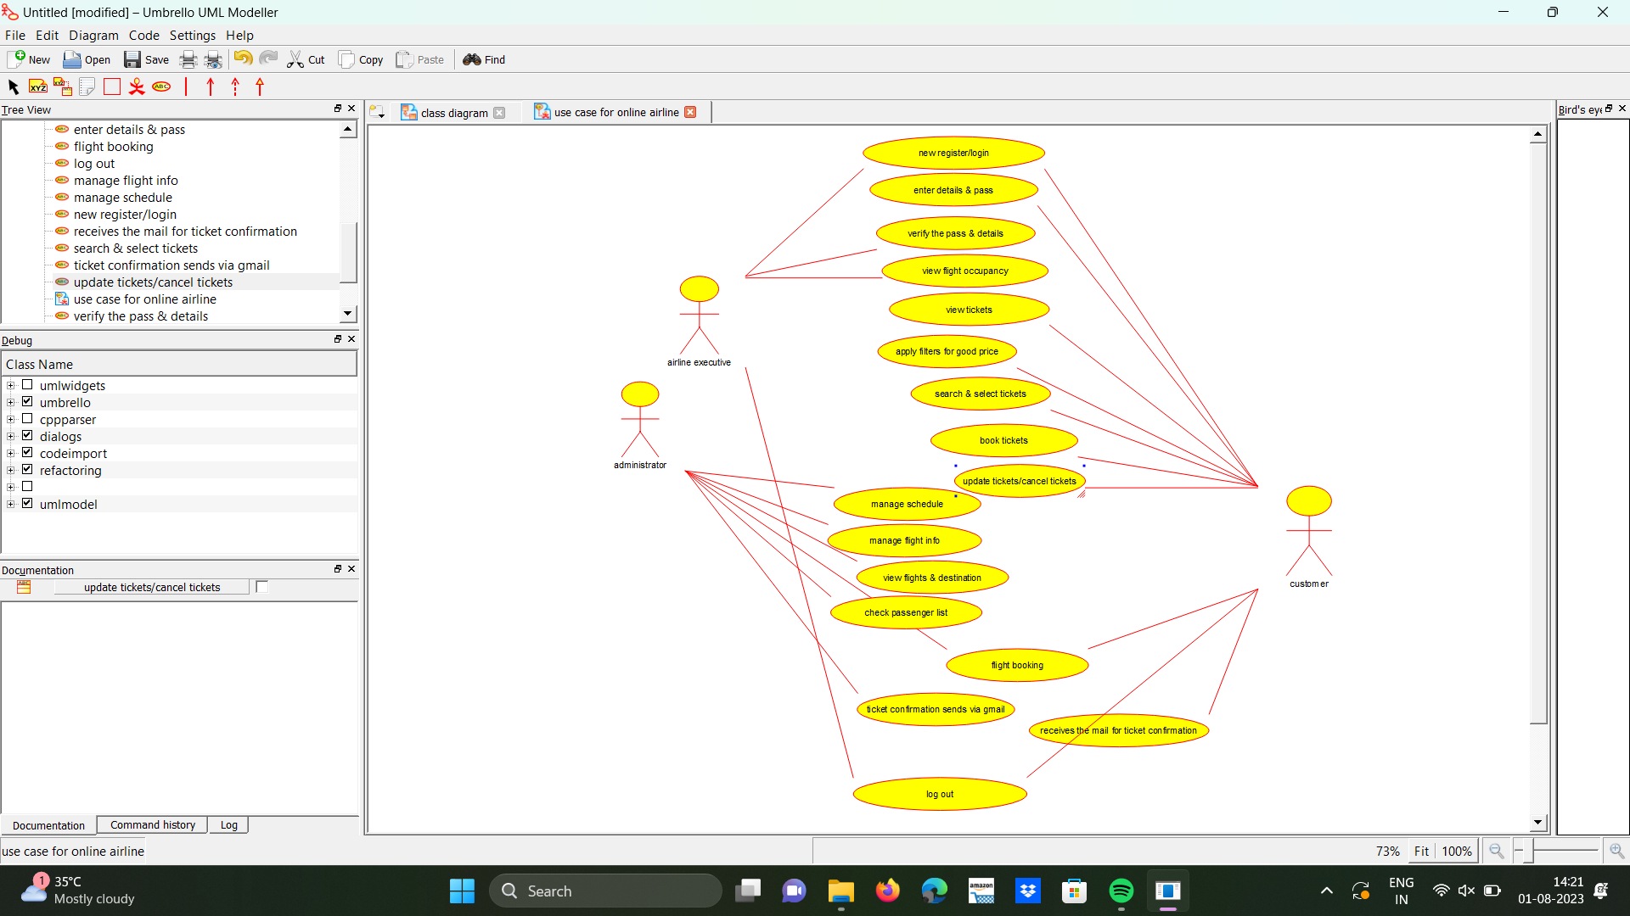

**EXPERIMENT NUMBER 8:** Make an Online Airline Reservation System. The activities of the Online Airline Reservation system are listed below user, admin, LOGIN, MANAGE CLASSES, MANAGE WAITING LIST, MANAGE HOLDS, MANAGE DEADLINES, LOGOUT, using this has a step-by-step process draw a CLASS diagram.

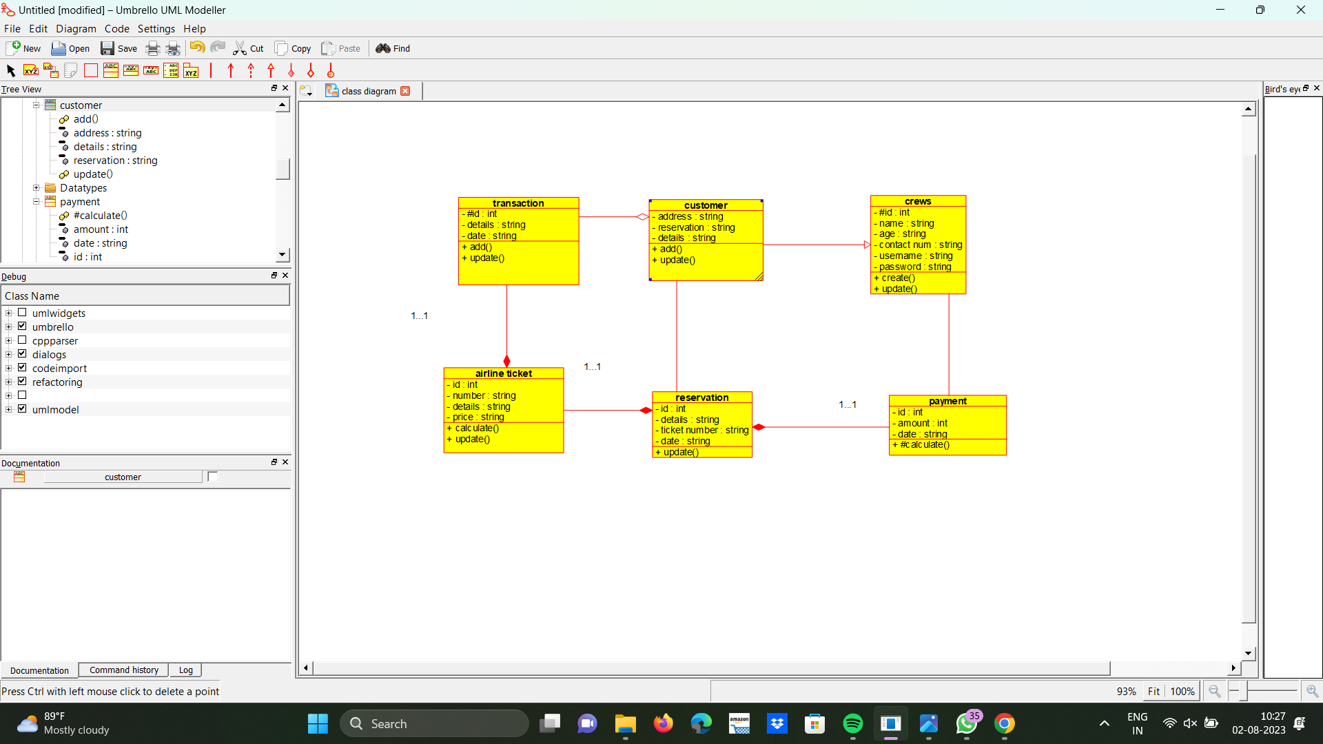

**EXPERIMENT NUMBER 9:** Draw a Class diagram for Online Voting System using CASE tools. vote is an election system that facilitates voters to record their secure and secret ballot electronically. It has a friendly user interface and enables voters to cast their votes in a few simple steps. We ensure the authenticity of the voters and the votes cast by them along with non-traceability of the casted vote elaborate the whole process of e-voting.

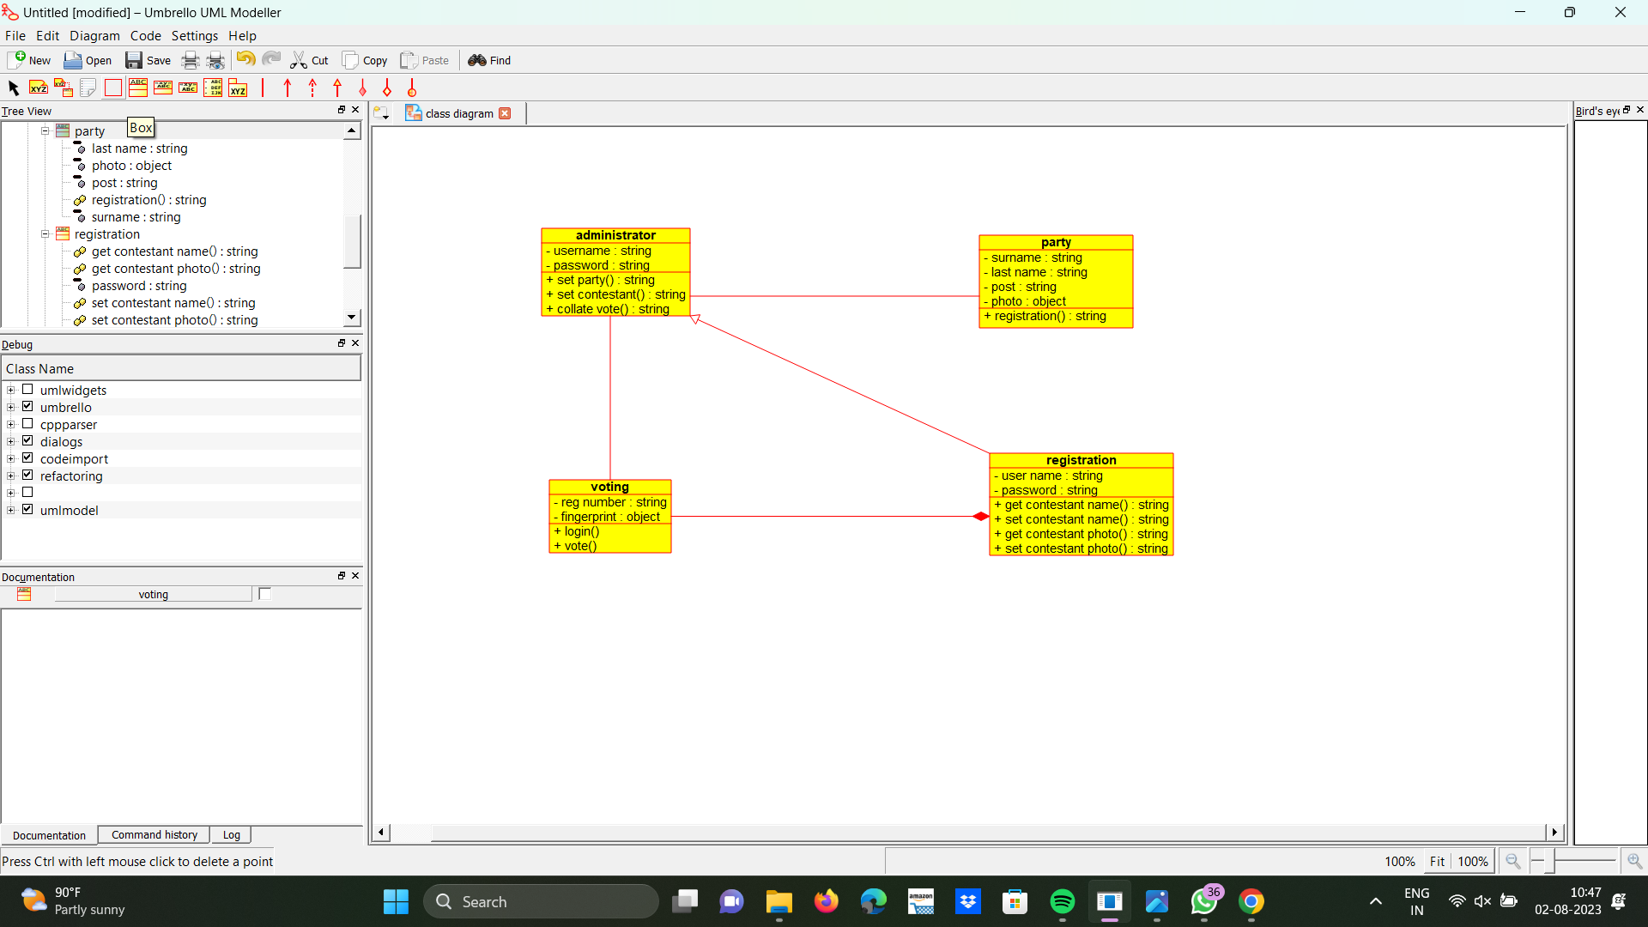

**EXPERIMENT NUMBER 10:** Draw a Class diagram for Library Management System using CASE tools. Designing use case diagram for the library management system. User who registers himself as a new user initially is regarded as staff or student for the library system. Librarians have a key role in this system. Librarian adds the records in the library database about each student or user every time issuing the book or returning the book or paying a fine. Design the class diagram for this.

